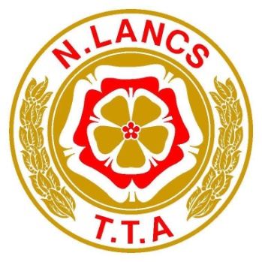
Founded 1928
Pomoted on behalf of Cycling Time Trials under their rules and regulations
Sunday 13th June 2021
GEORGE NOWLAND MEM0IRAL 100-L10010 Incorperating NLTTA 100 mile Chanpionship
Result Sheet
Event Secretary: Nigel Clementson: 80 Shevington Moor, Standish, Wigan. WN60SE.
PRIZES:
Fastest Gentleman:
1st Tom Hutchinson Team Bottrill 3:26:34 £60
2nd Tommy Murray GS Metro 3:32:44 £50
3rd Alex Royle Manchester Bicycle club 3:33:42 £40
4th Francis Woodcock Team SB Hub 3:38:43 £30 NLTTA Champion 2021
5th Matt Brooke Socks4Watts RT 3:40:50 £20
Fastest Lady:
1st Lizi Duncombe Socks4Watts RT 3:48:35 £60
2nd Christina Murray Army Cycling 4:02:06 £50
3rd Kelly Warrington Racing Chance Foundation 4:12:02 £40 NLTTA Champion2021
4th Joanna Rea Team Kirkley Cycling 4:12:28 £30
5th Joanna Cebrat Bury Clarion 4:15:26 £20
10TH Derek Parkinson Springfield Financial RT 3:46:22 £20
20th James Hall Manchester Triathlon Club 3:54:50 £20
30th Dave Berry Wigan Wheelers CC 4:09:17 £20
40th Mark Livingston Total Triathlon Training 4:16:26 £20
50th David Hildtch Ribble Valley C&RC 4:25:41 £20
Last place: Lanterne Rouge Lois Muir Cleveland Wheelers CC 5:05:17 Paul Hewitt vouchers £20
Team of 3: Adam Taylor 3:50:21 Richard Collins 4:06:36 and Dave Berry 4:09:17 Wigan Wheelers NLTTA Champions 2021
Mixed or men Paul Hewitt vouchers £20 each
(One rider one prize apart from team prize)
Big THANK YOU to our sponsors: Paul Hewitt cycles

Well done to hall the prize winners and a special mention on Lizi Duncombe on breaking the old ladies course record by 2mins 31sec with 1:48:35.
Good luck with your RRA 100m record attempt.

Big THANK YOU to ALL the marshals. It’s a long day out there.

